**Portfolio Analysis Part I**

*** All tables and graphs generated from monthly return data on four assets (ORCL, BA, GE, and MSFT)

** Return data from 1/1/1987 to 4/1/2019 found on <https://finance.yahoo.com/>

|  |  |  |  |  |  |  |
| --- | --- | --- | --- | --- | --- | --- |
| **Monthly Return Summary Statistics** | | | | | | |
|  | **Min.** | **1st Qu.** | **Median** | **Mean** | **3rd Qu.** | **Max.** |
| **ORCL** | -0.441 | -0.043 | 0.022 | 0.025 | 0.081 | 0.653 |
| **BA** | -0.346 | -0.034 | 0.016 | 0.012 | 0.067 | 0.236 |
| **GE** | -0.298 | -0.035 | 0.002 | 0.005 | 0.045 | 0.342 |
| **MSFT** | -0.344 | -0.038 | 0.021 | 0.020 | 0.065 | 0.408 |

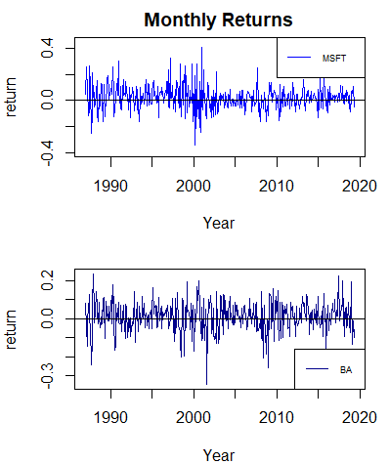

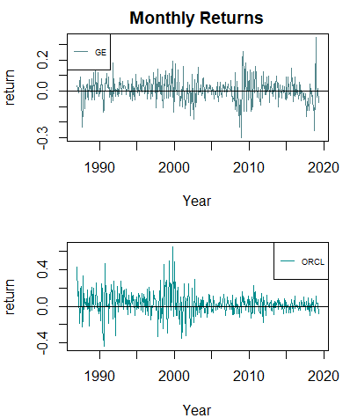

|  |  |  |  |  |
| --- | --- | --- | --- | --- |
| **Additional Monthly Return Statistics** | | | | |
|  | **mean** | **var** | **sd** | **skewness** |
| **ORCL** | 0.0246 | 0.0163 | 0.1278 | 0.5301 |
| **BA** | 0.0121 | 0.0063 | 0.0795 | -0.4403 |
| **GE** | 0.0050 | 0.0055 | 0.0742 | -0.0802 |
| **MSFT** | 0.0203 | 0.0087 | 0.0934 | 0.3629 |

